Initial Set Up and Configuration

Configuring Scanning
- Turn on ScanSKU and plug it into power
- Open the App Drawer and open the “Scanner” app. Go to settings, then disable Sounds (the SBMOM app has its own sounds), and tap on the cog next to Additional content and select the “Enter Key” option and press OK.
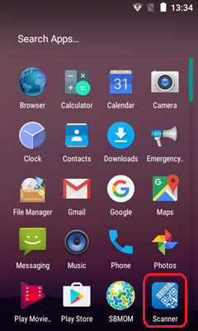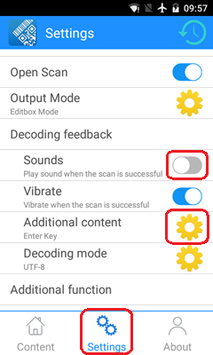

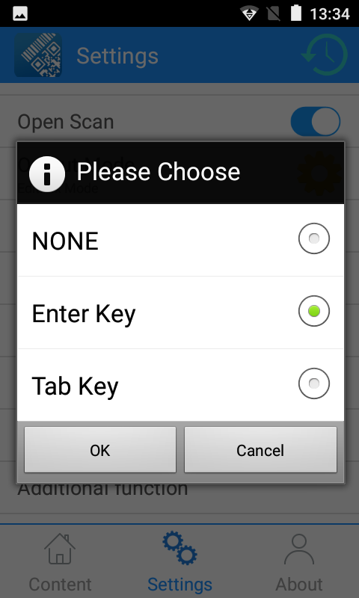

Remove Screen Lock (Optional)
- Open the settings app.
- Tap Security -> Screen lock -> None

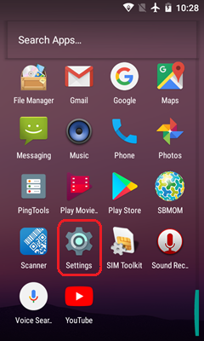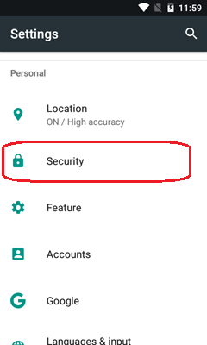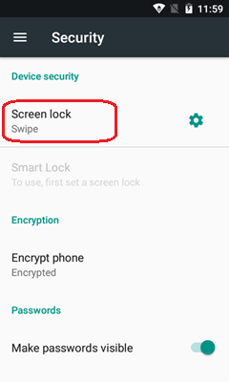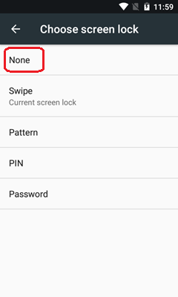

Increase Screen Timeout (Optional)
- Open the Settings app
- Tap Display -> Sleep -> Select your preferred value
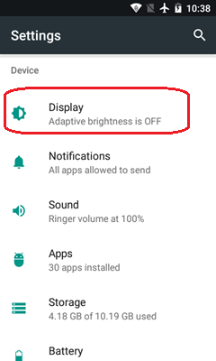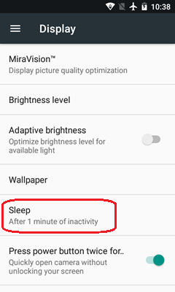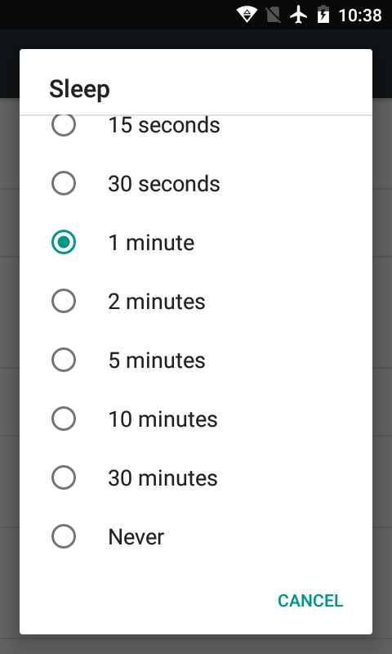

How to login
The default values that are populated when the app is opened should work. If not, these are the values.
- The server is: ___________
- The username is:
- The password is: __________
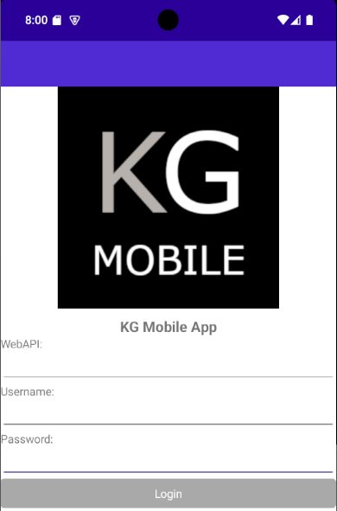

Using SBMOM
Functionality is selected using the side menu. The menu can be accessed by either swiping from the left of the screen or tapping on the menu (hamburger) icon.
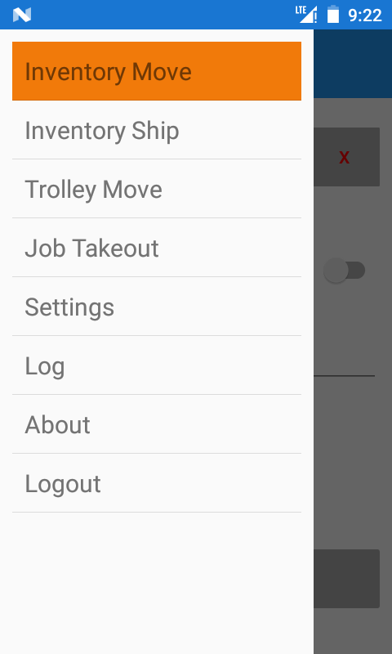

Inventory Move
Inventory move is used to move a part into a trolley.

Auto Inventory Move

- Select Inventory Move from the menu.

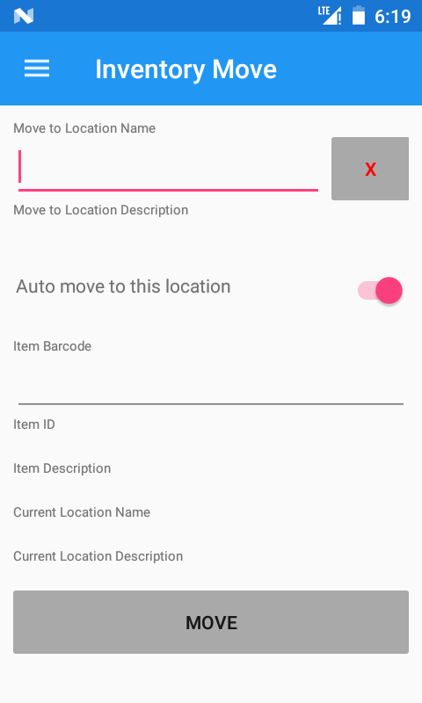
- Scan a location barcode to move the inventory to.
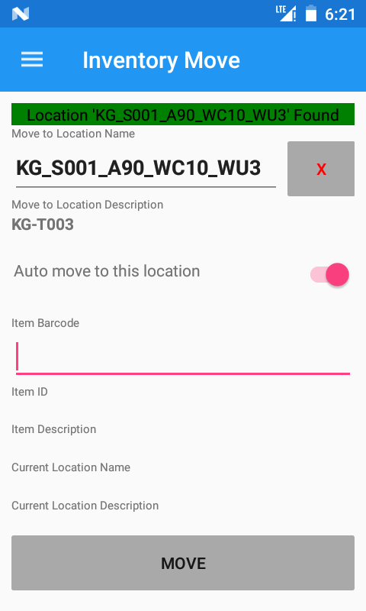

- Scan the piece to move.
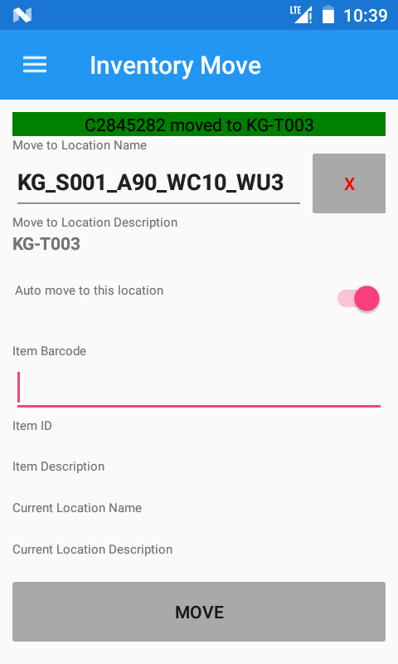

The piece is automatically moved to the trolley location after scanning. A notification banner and sound confirms a successful move.

Manual Inventory Move
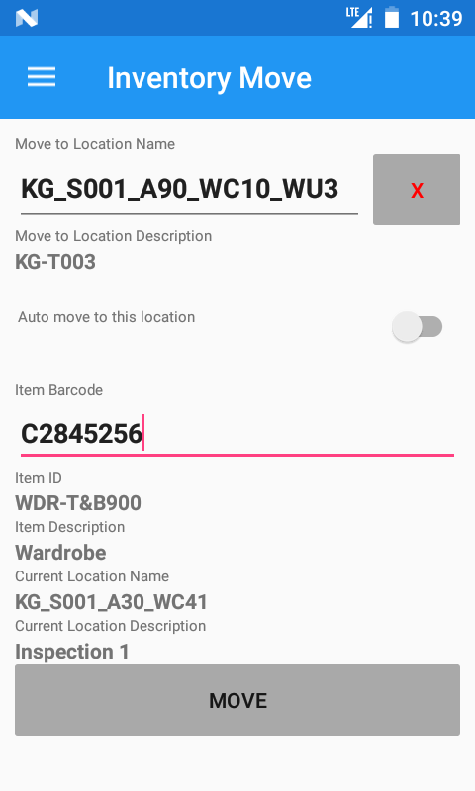

To check the item details before moving it, turn off “Auto move to this location”.
After scanning a piece, the item and current location will be displayed.
To move to piece, press the “Move” button.

Inventory Move Errors

Piece exists in Vertical Store
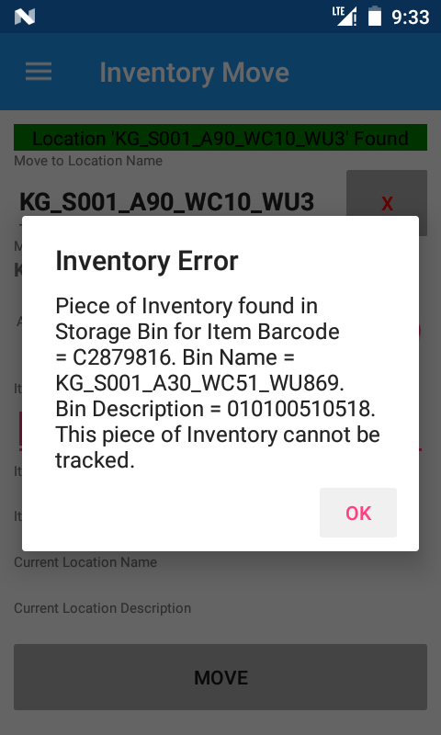

If the current location of a piece is determined to be in a bin in the vertical stores, the piece will not be moved.

Location Does not Exist

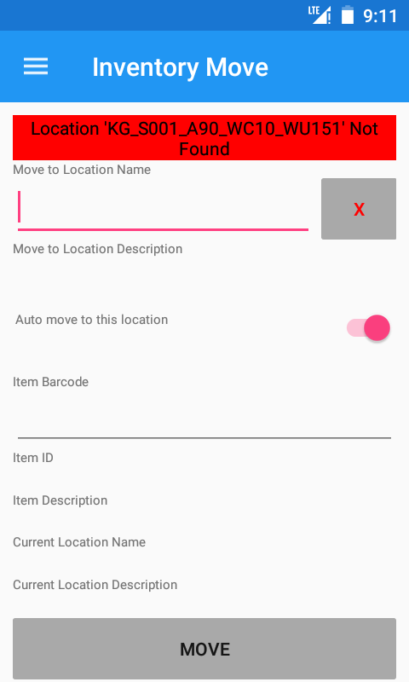

The trolley location scanned does not exist.
Check the location name or the location barcode.

Item does not exist – Auto Mode
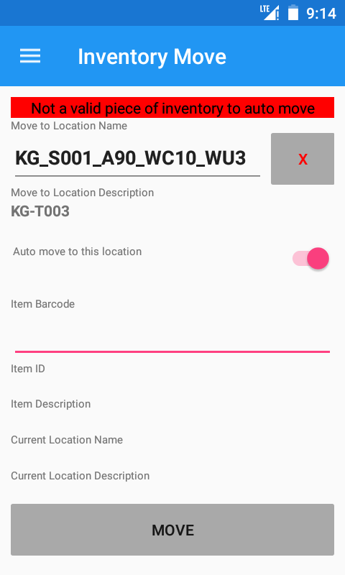

The item scanned was not found.
Check the item name or the item barcode.

Item Does not Exist - Manual Mode

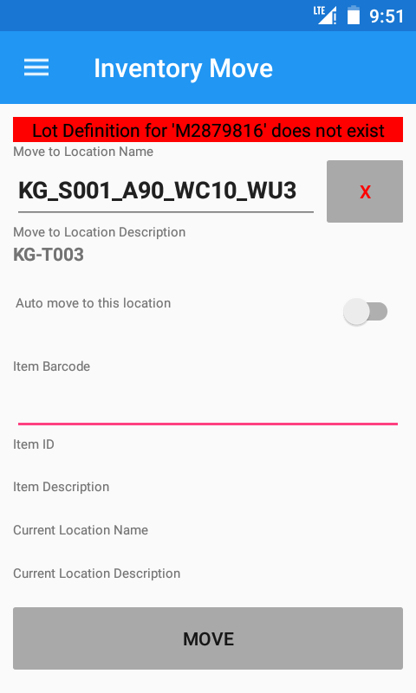

The Item was not found.
Check the item name or item barcode.

Blank Location Name

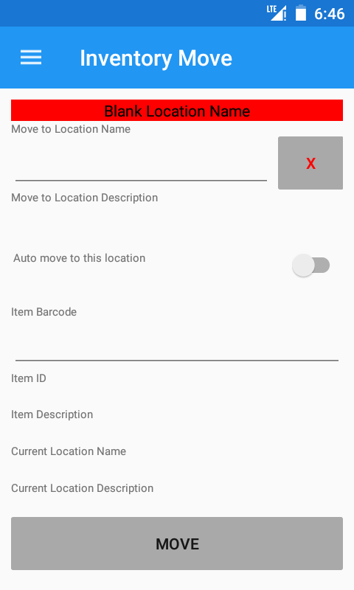

A location hasn’t been specified.
Try scanning the location barcode again.

Inventory Ship
Inventory ship is used to delete all items from a trolley.

Ship all
- Select Inventory Ship from the menu.
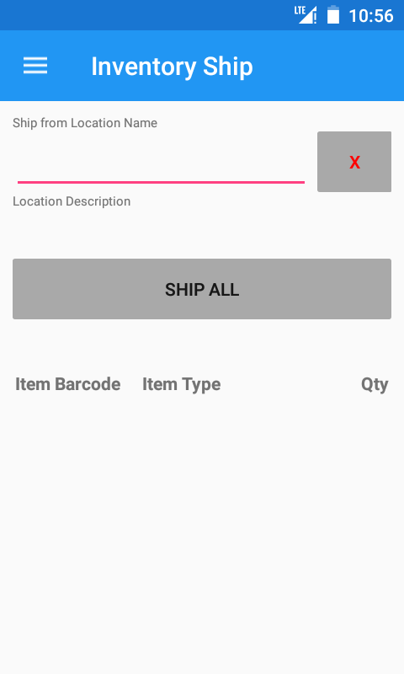
- Scan the location to ship inventory from.
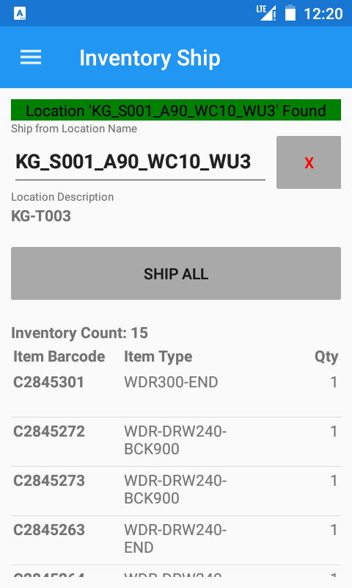

A list of current inventory in that location will be shown.

- Click “Ship All”
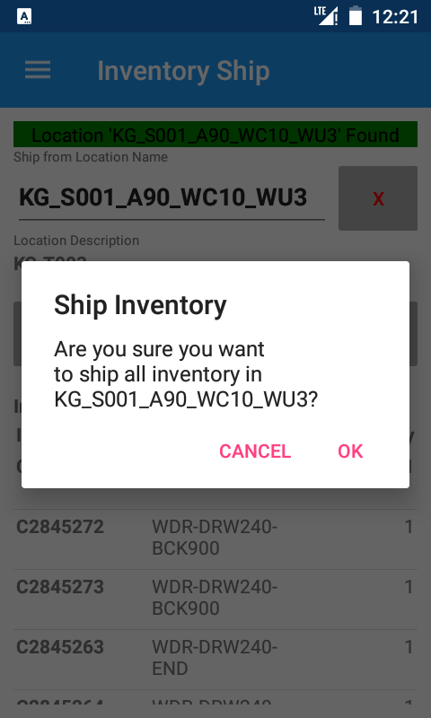
- Confirm the action by clicking “Ok”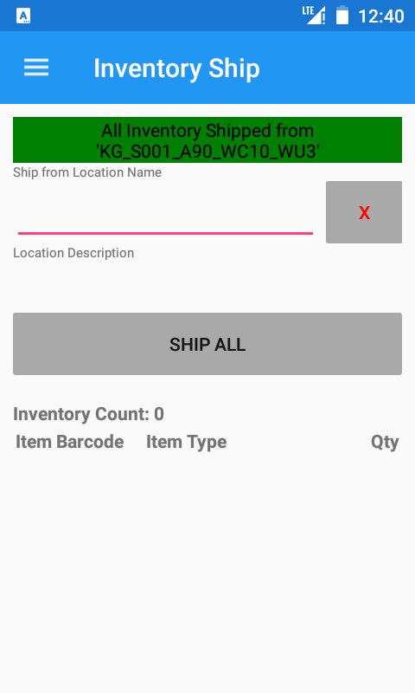

Inventory Ship Errors

Location Not Found

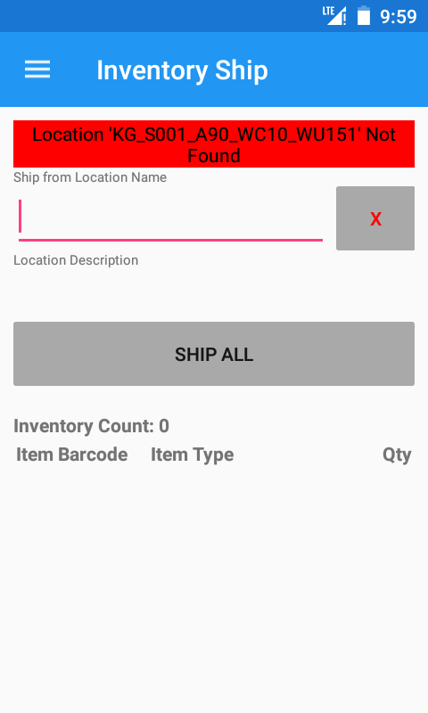

The location was not found.
Check the location name or location barcode.

No Inventory in Location
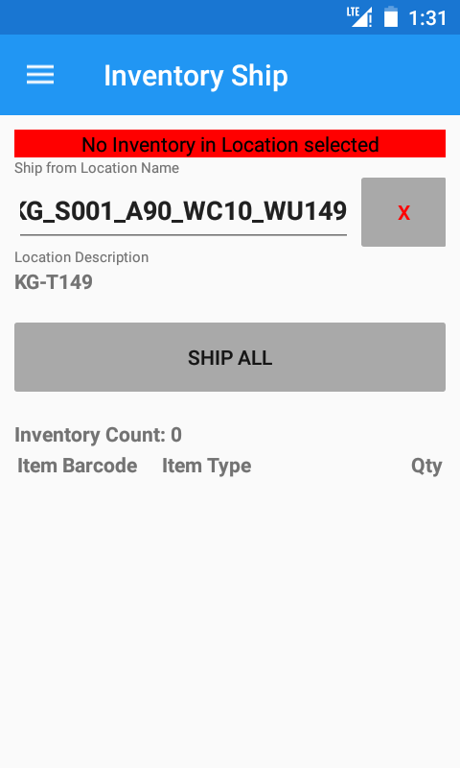

There are no pieces in this location.

Blank Location Name



No location name was specified.
Try scanning the location barcode again.

Trolley Move
Trolley Move is used to move the trolley to a different location.

Move

- Select Trolley Move from the menu.
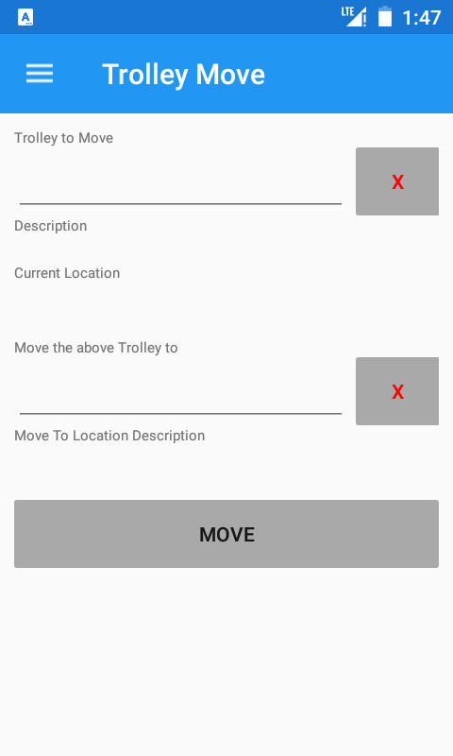
- Scan the trolley to move.
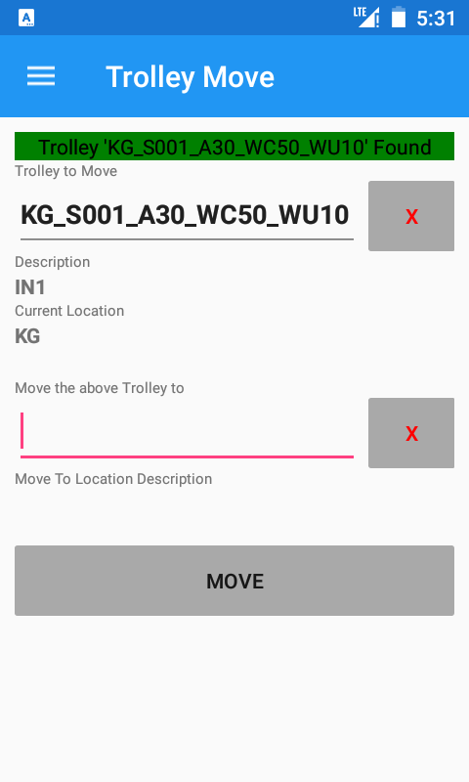
- Scan the location to move the trolley to.
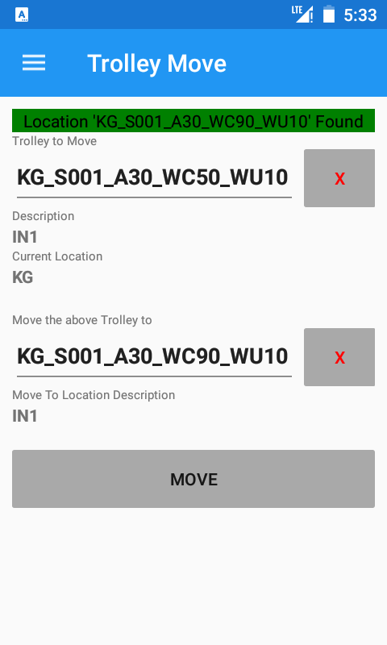
- Press “Move”.
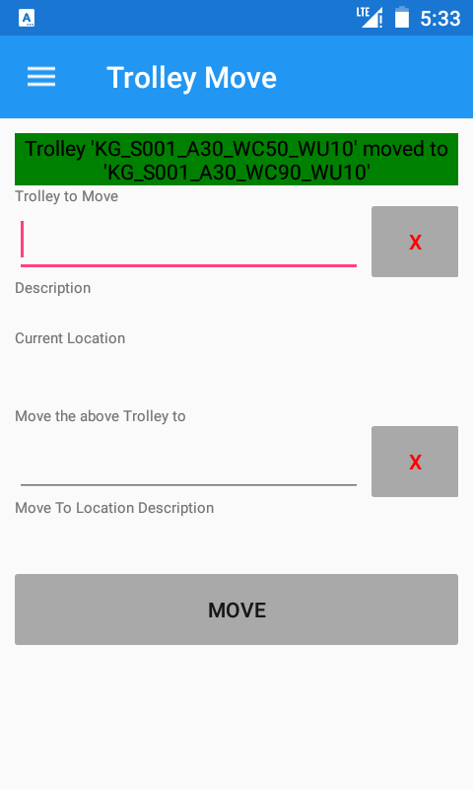

Trolley Move Errors

Trolley Not Found

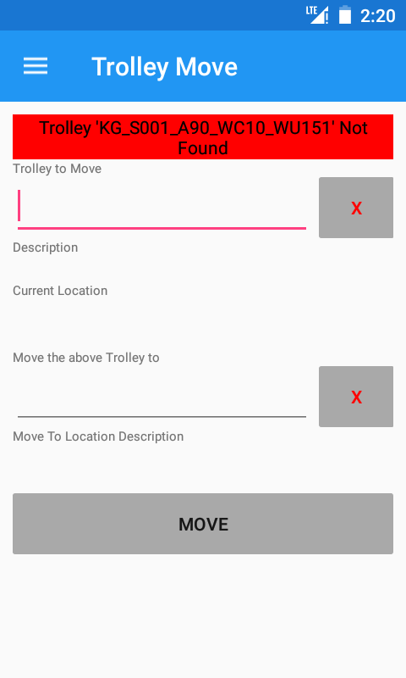

The trolley location has not been found.
Check the trolley name or trolley barcode.

Not a Movable Trolley

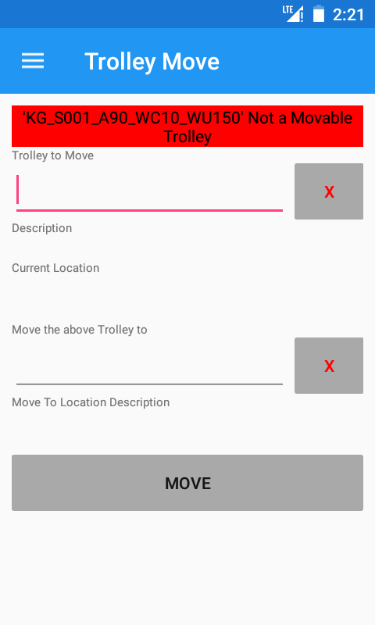

The trolley scanned is not movable.
Check the trolley name or trolley barcode.

Location Not Found

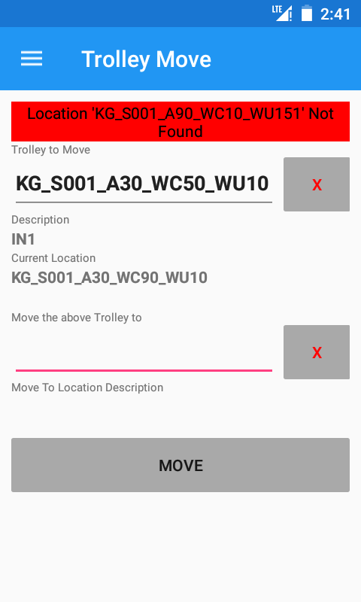

The location has not been found.
Check the location name or location barcode.

Blank Trolley Name

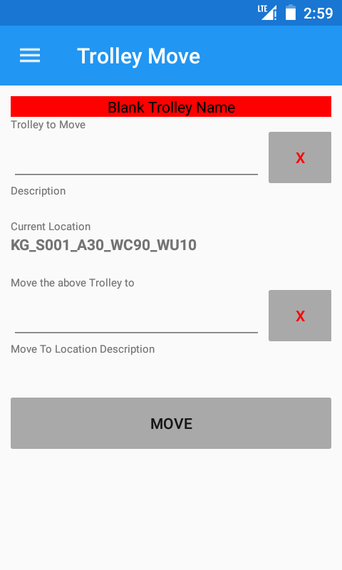
The trolley name is blank.
Try scanning the trolley barcode again.

Blank Location Name

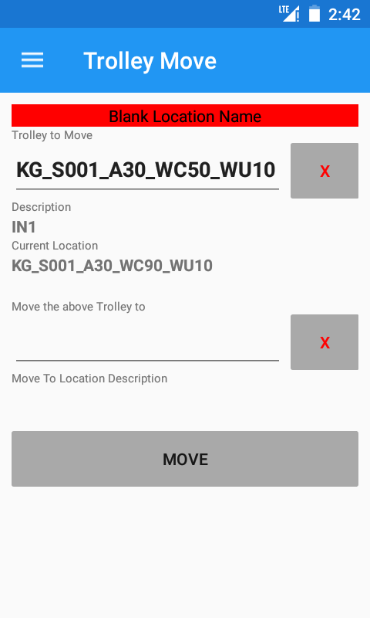
The location name is blank.
Try scanning the location barcode again.

No Trolley to Move Selected

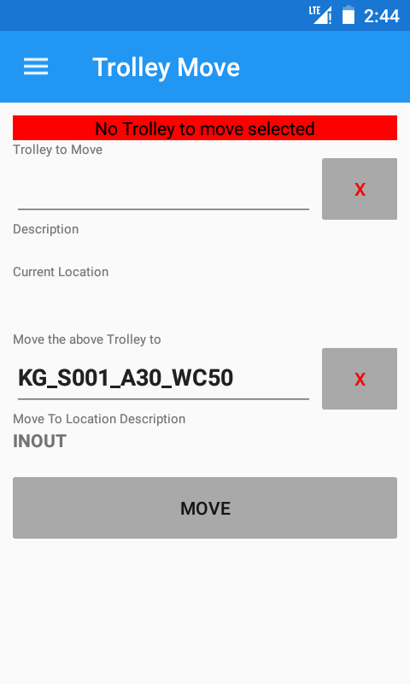

The trolley name is blank.
Scan the trolley name.

No Location to Move to Selected

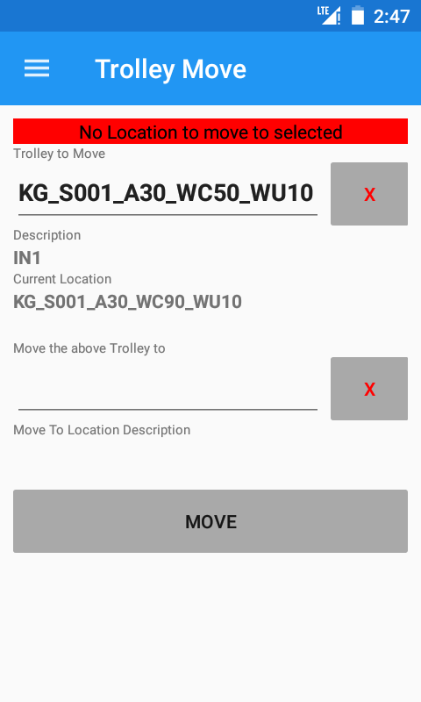

The location name is blank.
Scan the location barcode.

Nothing Selected
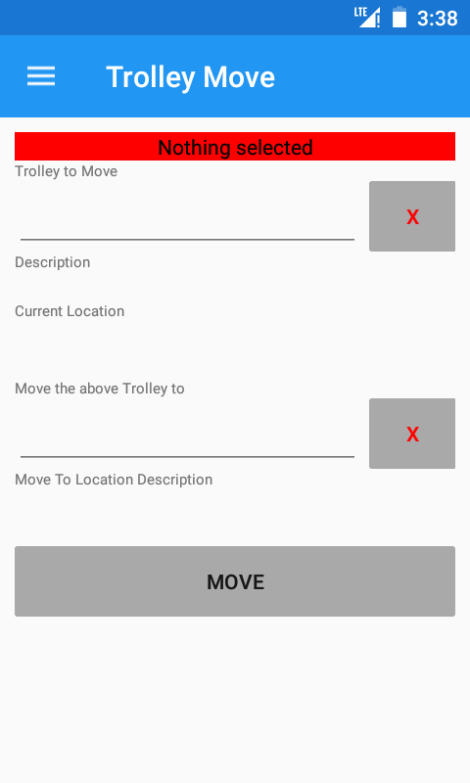

Both the trolley name and location names are blank.
Scan the trolley name and location name.

Job Takeout
Job Takeout is used to takeout pieces required for a cabinet.

Takeout

- Select Job Takeout from the Menu
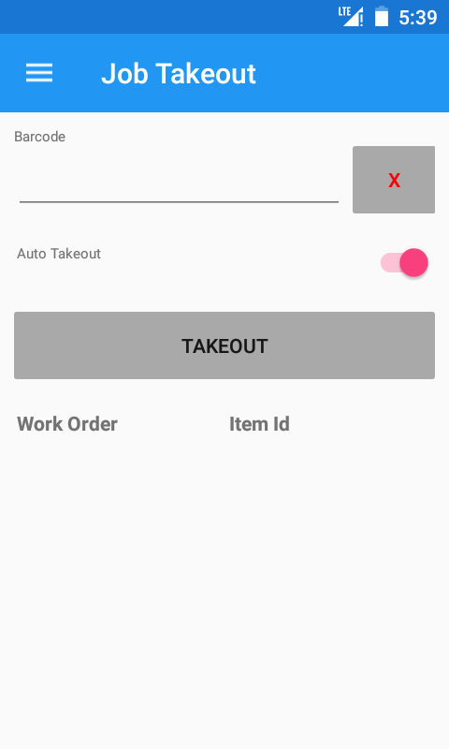
- Scan the cabinet barcode.
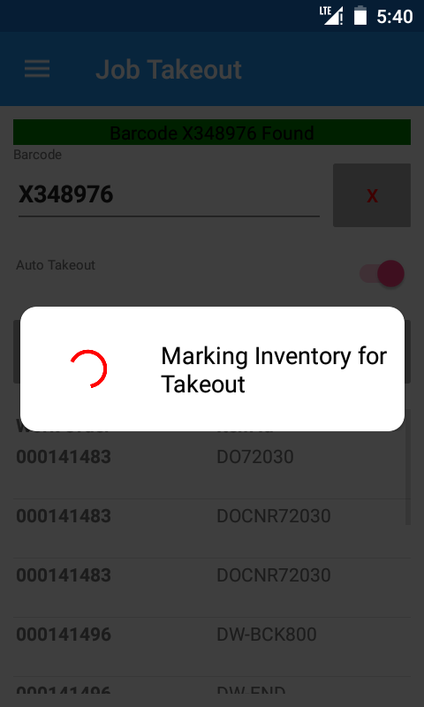

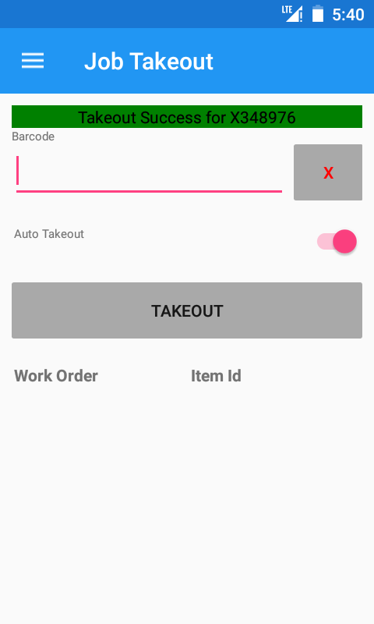

The relevant pieces are automatically marked for takeout after scanning. A notification banner and sound confirms a successful Job Takeout.

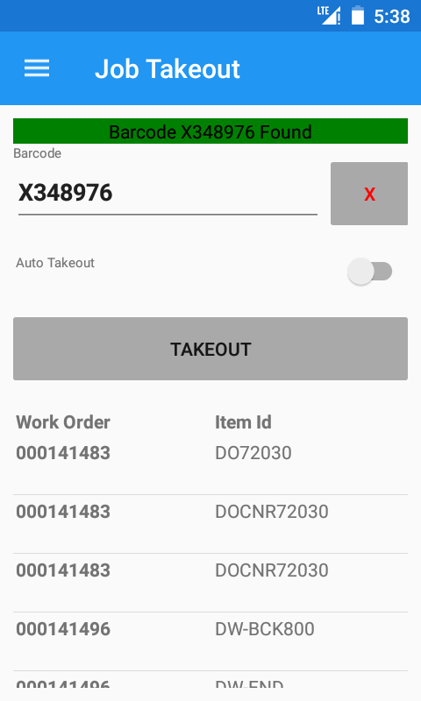

To review items that will be marked for takeout before marking them for takeout, turn off “Auto Takeout”.
After scanning a cabinet barcode, the work orders and item ids will be displayed.

To takeout the pieces, press the “Takeout” button.

Takeout Errors

Nothing to Takeout

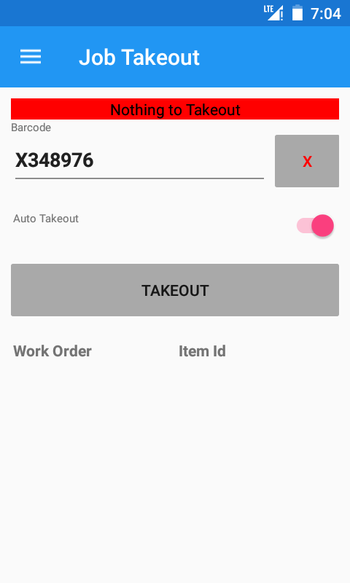

No pieces that are part of the specified cabinet barcode were found in a state to be taken out.
Check the locations of the relevant pieces.

Blank Barcode

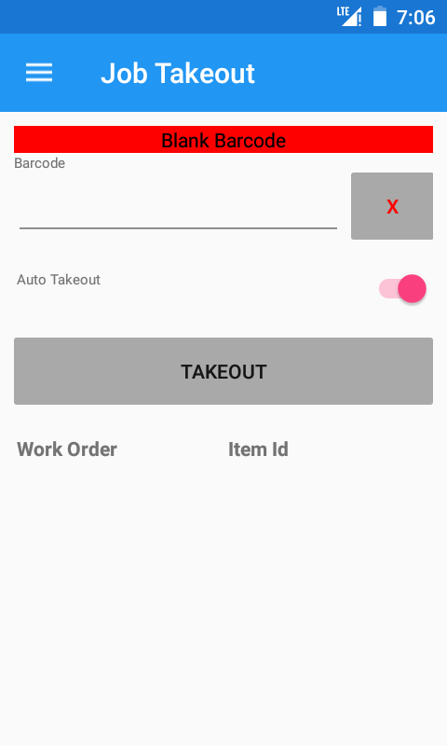

No barcode was provided.
Scan the Cabinet Barcode.

Barcode Not Found

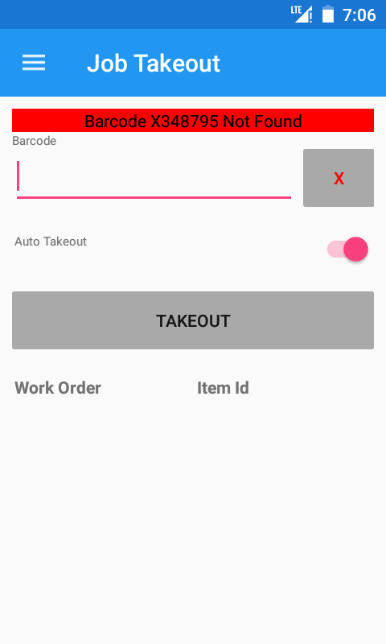

The specified barcode was not found in the system.
Check the Cabinet barcode.

Settings
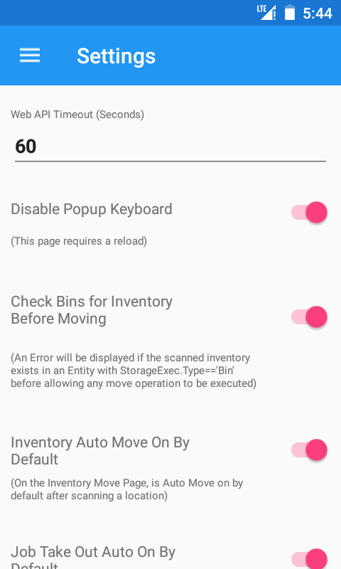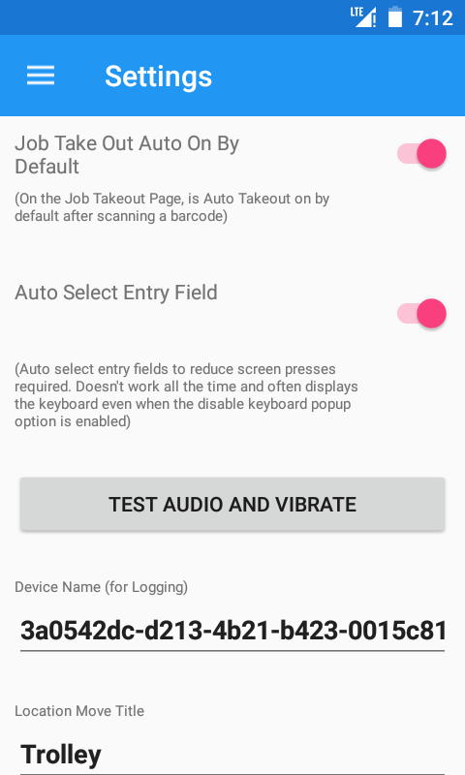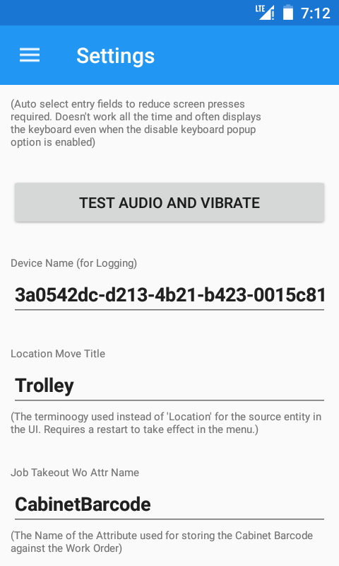

Web API Timeout
How long the app will wait for a response from the Web API (Default = 60)
Disable Popup Keyboard
If the onscreen keyboard should be displayed when an input field is selected (Default = true)
Check Bins for Inventory Before Moving
If inventory is attempted to be moved from a bin location (i.e. inside a vertical store), an error will be displayed. (Default = true).
Inventory Auto Mode On By Default
Determines if auto move is checked by default (Default = true)
Job Take Out Auto On By Default
Determines if auto take out is checked by default (Default = true)
Auto Select Entry Field
Determines if the input field is automatically selected (i.e. Location Name field on Inventory Move) (Default = True)
Test Audio and Vibrate
Used to check the volume of the speaker and that the vibration motor is working.
Device Name
This is used to identify the device for debugging purposes
Location Move Title
Used to label the Location Move (Default = Trolley)
Job Takeout Wo Attr Name
The name of the work order attribute which holds the cabinet barcode (Default = CabinetBarcode).

Log
Holds the last operations performed on the device.
The Log can be cleared by pressing the “Reset Log” Button.
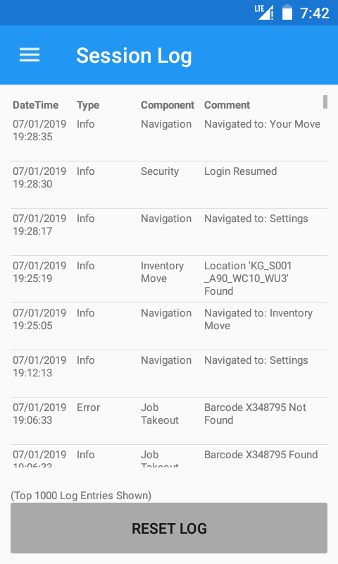

About
Displays information about the app such as the version and build number.
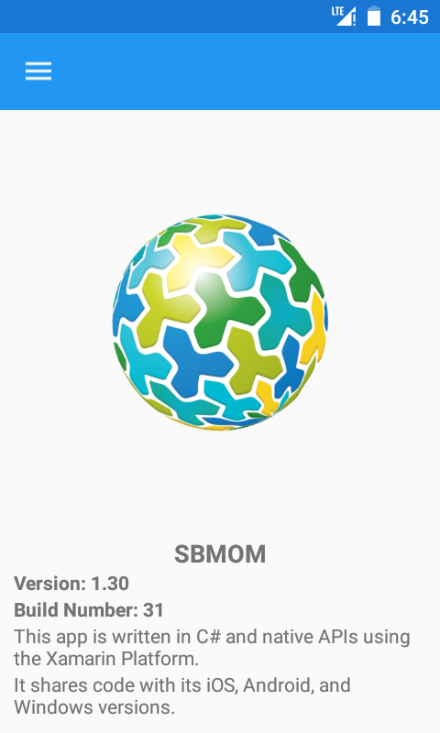

Logout
Pressing “Logout” from the side menu will log the current user out of the app.

SBMOM Web API
The web api is located on WSPRODWWSQL001.
The SBMOM Android application makes calls to this Web API to talk to the MES system.
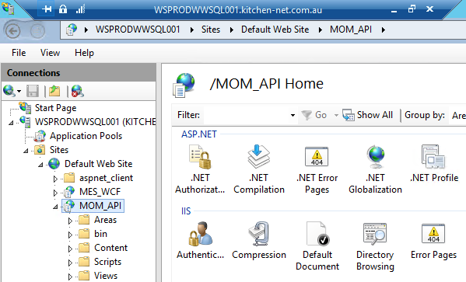
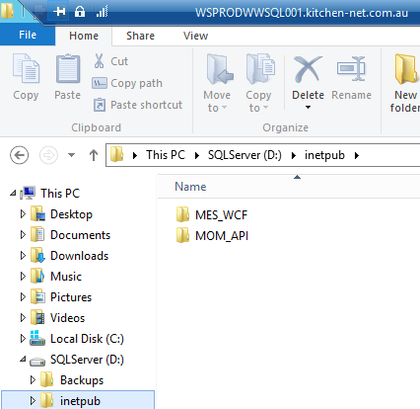

SBMOM Diagnosis Database
The SBMOM diagnosis database stores a log of each interaction made in the SBMOM app. This is to diagnose any issues or bugs in the application.
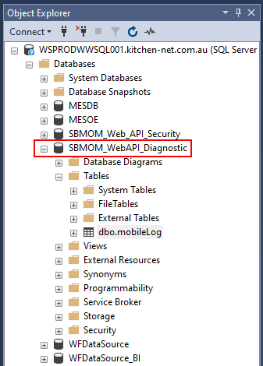

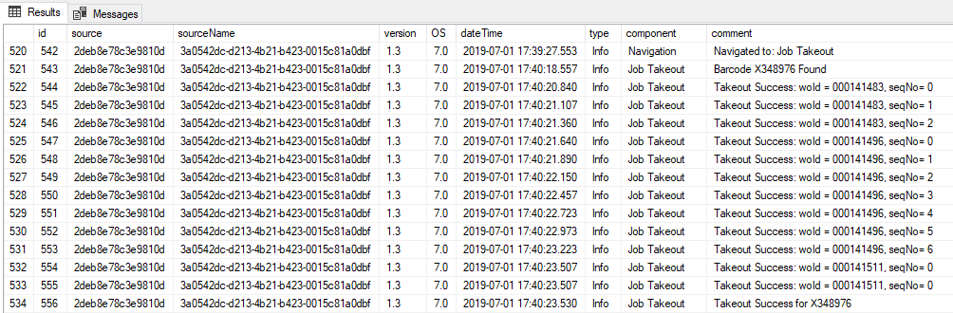

SBMOM Security Database
The SBMOM security database contains security releated components for the Web API.
